**Assignment – 1**

**PROG32356 – .NET Technologies using C#**

**Instructor: Fagun Vankawala**

**StudentID: 991667498**

**Student Name: Noopur Vijaykumar Patel**

**6th June 2024**

**Output Screenshots:**

1. **Initial program run(menu)**

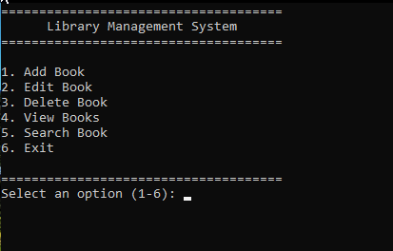

1. View Available books

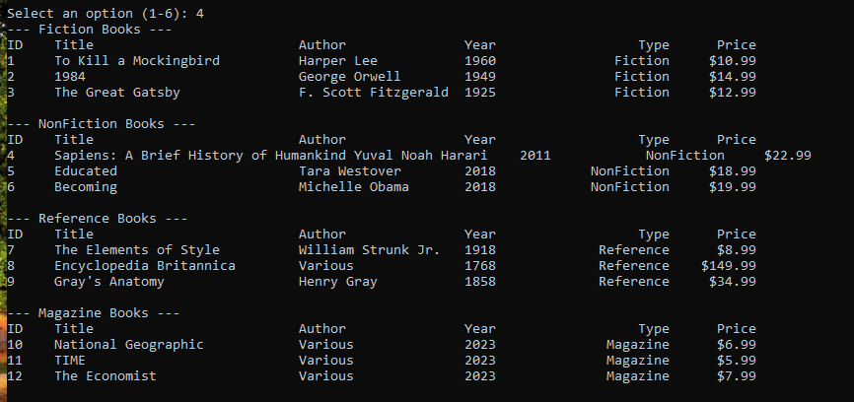

1. Add a new book

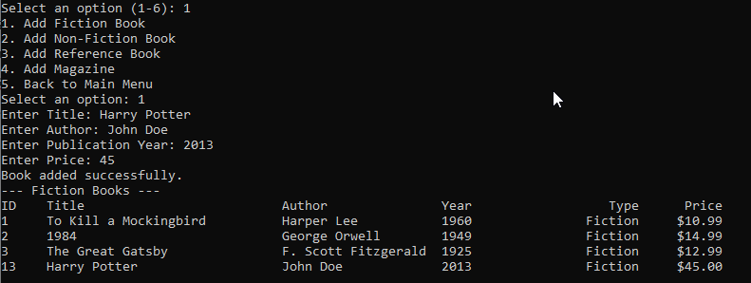

1. Edit a book

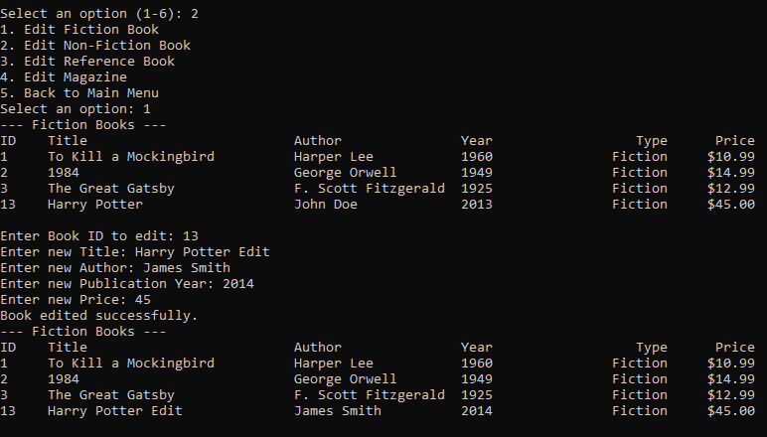

1. Search a book

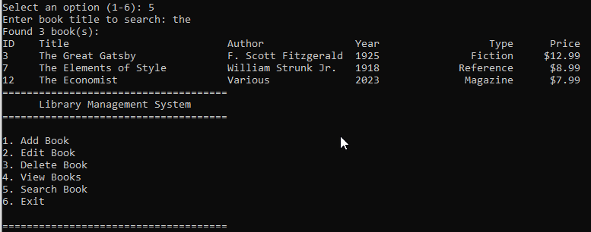

1. Invalid user input Validation

